1. Simple Java Console App (Baseline
CI/CD)
TASK : Create Maven project with Junit tests
• Create a Maven based application by following standard Maven directory structure.
• Write the code in Visual Studio and push it to your GITHUB repository.
• Modify the code and commit the updates back in GITHUB.
• Using Jenkins configure the job as pipeline and create the stages for the Continuous
Integration process.
• Containerize the application using Dockerfile and display the stages in stage view in
Jenkins.
a. Addition operation
b. Evenodd numbers
c. Multiplication
d. Factorial of the given numbers
e. Prime number.

2. Simple Static Web page.
TASK : CI and CD
• Write the code in Visual Studio and push it to your GITHUB repository.
• Modify the code and commit the updates back in GITHUB.
• Using Jenkins configure the job as pipeline and create the stages for the CI and CD
process.
• Containerize the application using Dockerfile and display the stages in stage view in
Jenkins.
• Create kubernetes cluster and visualize the deployment in the given node port.
a. The student results
b. Create some five events during Rivera.
c. The Conference information and its full details.
d. The price list of the items
e. The timetable of a student.

STEP 1 — Understand Question 2e
Your task (from the PDF):
- Create static web page
- Push code to GitHub
- Configure Jenkins Pipeline
- Dockerize application
- Deploy using Kubernetes NodePort
- Show Stage View + Console Output
For 2e → Student Timetable page.

STEP 2 — Create Project Folder
Create this folder in Desktop
student-timetable-app
Inside create this structure:
student-timetable-app
│
├── index.html
├── Dockerfile
└── deployment.yaml

STEP 3 — Create Static Web Page
index.html
<!DOCTYPE html>
<html>
<head>
<title>Student Timetable</title>
<style>
table {
border-collapse: collapse;
width: 70%;
margin: auto;
}
th, td {
border: 1px solid black;
padding: 10px;
text-align: center;
}
th {
background-color: #4CAF50;
color: white;
}
</style>
</head>
<body>
<h2 style="text-align:center;">Student Weekly Timetable</h2>
<table>
<tr>
<th>Day</th>
<th>9-10</th>
<th>10-11</th>
<th>11-12</th>
<th>1-2</th>
<th>2-3</th>
</tr>
<tr>
<td>Monday</td>
<td>Math</td>
<td>Java</td>
<td>DBMS</td>
<td>AI</td>
<td>Sports</td>
</tr>
<tr>
<td>Tuesday</td>
<td>Physics</td>
<td>Java</td>
<td>DBMS</td>
<td>AI</td>
<td>Library</td>
</tr>
<tr>
<td>Wednesday</td>
<td>Math</td>
<td>Python</td>
<td>Cloud</td>
<td>AI</td>
<td>Sports</td>
</tr>
<tr>
<td>Thursday</td>
<td>Physics</td>
<td>Java</td>
<td>DBMS</td>
<td>Cloud</td>
<td>Library</td>
</tr>
<tr>
<td>Friday</td>
<td>Math</td>
<td>Python</td>
<td>DBMS</td>
<td>AI</td>
<td>Sports</td>
</tr>
</table>
</body>
</html>
STEP 4 — Create Dockerfile
Create file:
Dockerfile
Paste:
FROM nginx:latest
COPY index.html /usr/share/nginx/html/index.html
EXPOSE 80

STEP 5 — Test Docker Locally
Open terminal in project folder.
Run:
docker build -t timetable-app .
Then:
docker run -p 8081:80 timetable-app
Open browser:
http://localhost:8081
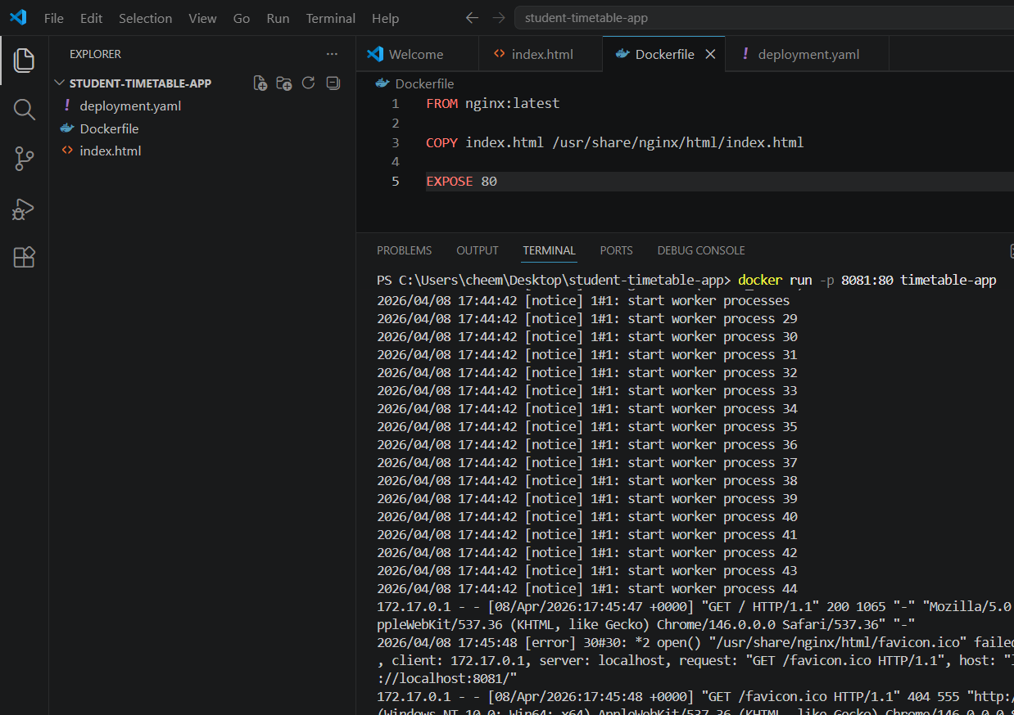

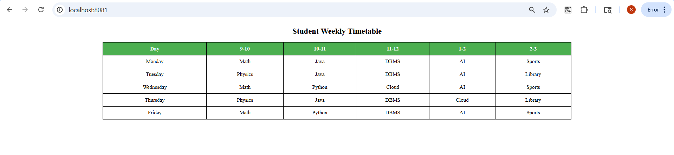

STEP 6 — Create GitHub Repository
Go to GitHub.
Create repository:
student-timetable-app
Then push code.
Commands:
git init
git add .
git commit -m "Initial timetable project"
git branch -M main
git remote add origin https://github.com/YOURUSERNAME/student-timetable-app.git
git push -u origin main

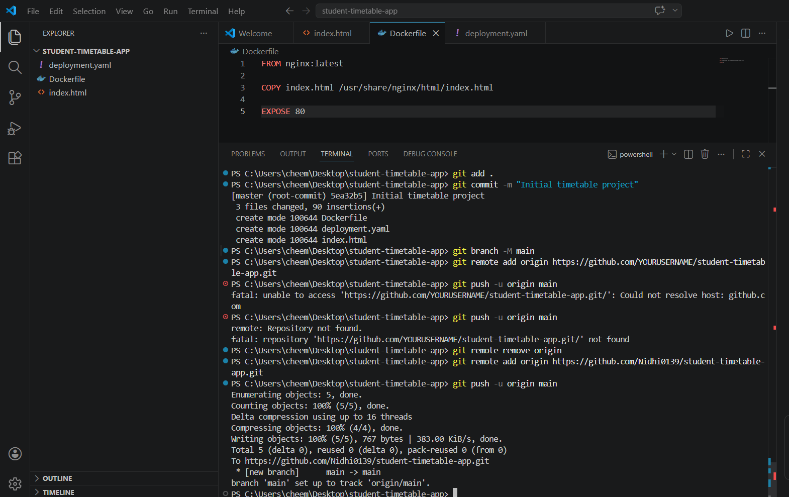

STEP 7 — Create Kubernetes Deployment File

Create file: deployment.yaml

apiVersion: apps/v1
kind: Deployment
metadata:
name: timetable-app
spec:
replicas: 2
selector:
matchLabels:
app: timetable
template:
metadata:
labels:
app: timetable
spec:
containers:
- name: timetable
image: YOUR_DOCKER_USERNAME/timetable-app:latest
ports:
- containerPort: 80
---
apiVersion: v1
kind: Service
metadata:
name: timetable-service
spec:
type: NodePort
selector:
app: timetable
ports:
- port: 80
targetPort: 80
nodePort: 30007

STEP 8 — Push Again to GitHub
git add .
git commit -m "Added Docker and Kubernetes"
git push
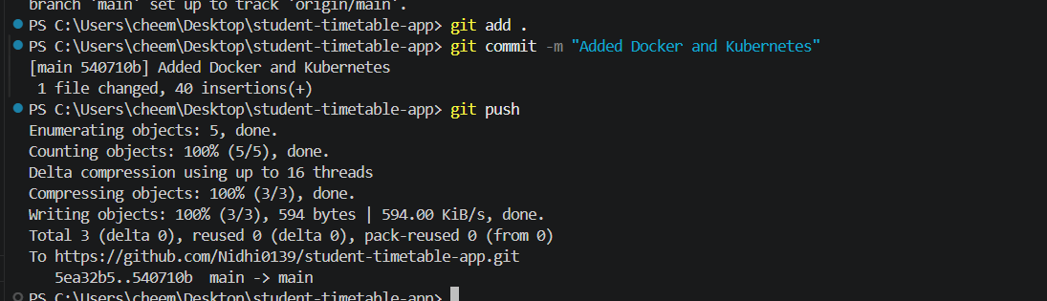

STEP 9 — Jenkins Pipeline
Create new pipeline job.
Name:
Timetable-CICD
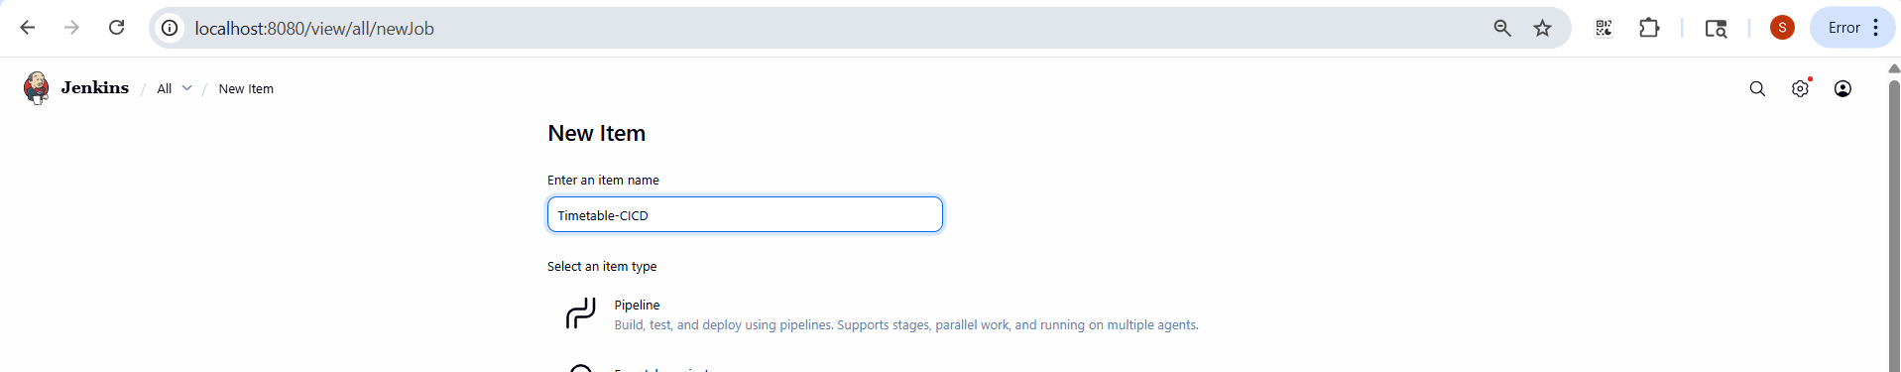

pipeline {
agent any

environment {
DOCKER_IMAGE = "nidhireddy11/conference-app:latest"
KUBECONFIG = "C:\\Users\\cheem\\.kube\\config"
}

stages {

stage('Clone Code') {
steps {
git branch: 'main',
url: 'https://github.com/Nidhi0139/student-timetable-app'
}
}

stage('Build Docker Image') {
steps {
bat 'docker build -t %DOCKER_IMAGE% .'
}
}

stage('Push Image') {
steps {
withCredentials([usernamePassword(
credentialsId: 'dockerhub-creds',
usernameVariable: 'USER',
passwordVariable: 'PASS'
)]) {

bat 'docker login -u %USER% -p %PASS%'
bat 'docker push %DOCKER_IMAGE%'
}
}
}

stage('Deploy to Kubernetes') {
steps {
bat 'kubectl apply -f deployment.yaml --validate=false'
}
}
}

post {
success {
echo 'CI/CD Pipeline executed successfully!'
}
failure {
echo 'Pipeline failed. Please check logs.'
}
}
}

C:\ProgramData\Jenkins\.jenkins\.kube

.kube- Config – check path

STEP 10 — Run Jenkins Pipeline
Click:
Build Now
Stages will appear:
Clone Repository
Build Docker Image
Push Image
Deploy Kubernetes
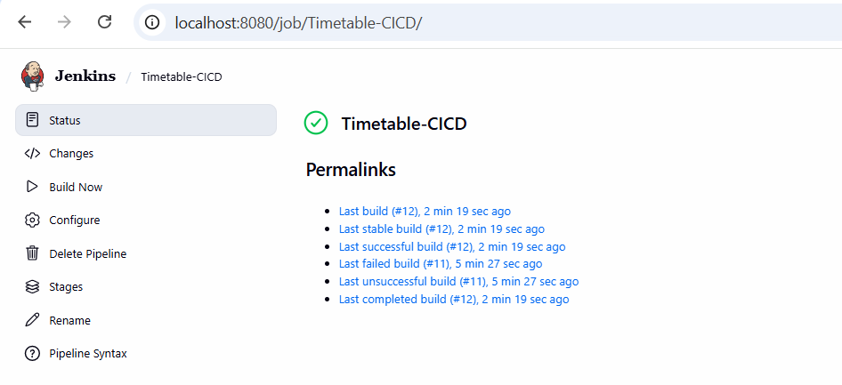

STEP 11 — Verify Kubernetes
kubectl apply -f deployment.yaml
Run:
kubectl get pods
and
kubectl get svc
Open browser:
http://localhost:30007
(if any changesss are there then)
kubectl delete deployment timetable-app
kubectl apply -f deployment.yaml
kubectl get pods

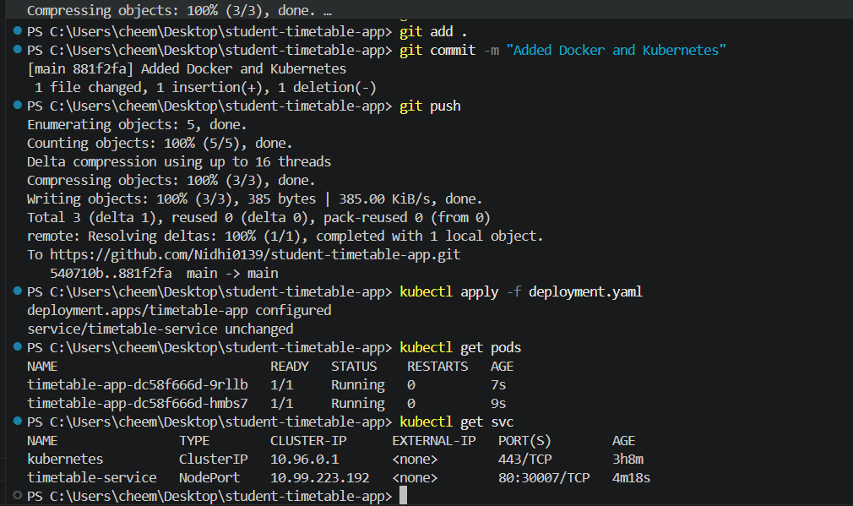
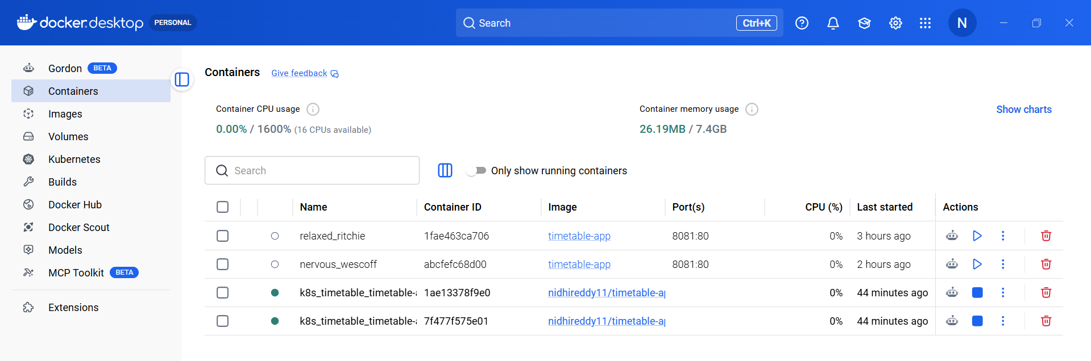
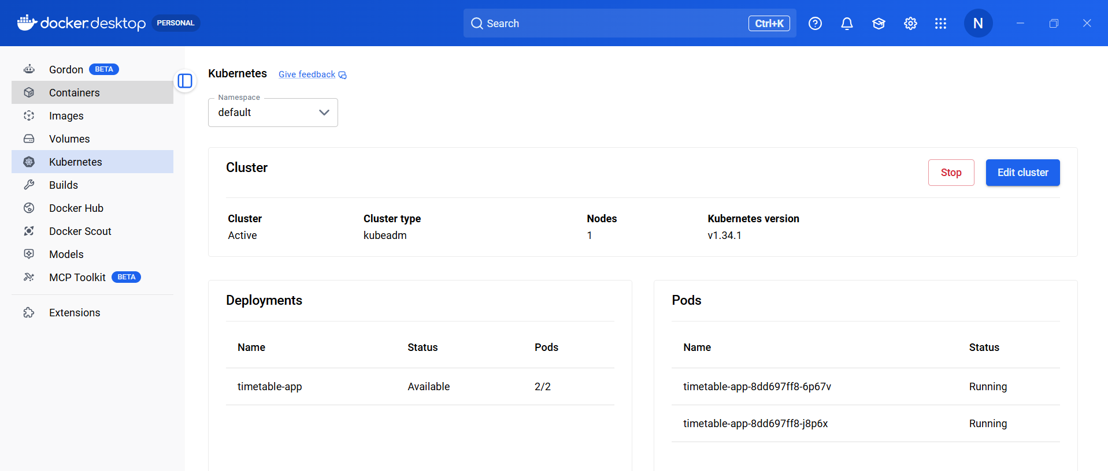

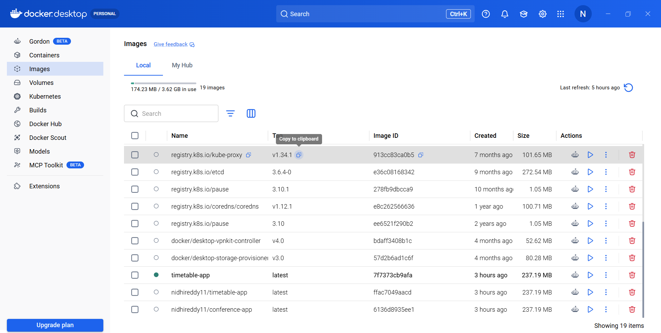

Step 1 — Create new project folder
Create folder:
price-list-app
Inside create:
price-list-app
│
├── index.html
├── Dockerfile
└── deployment.yaml
Step 2 — Create index.html
<!DOCTYPE html>
<html>
<head>
<title>Item Price List</title>
<style>
table {
border-collapse: collapse;
width: 60%;
margin: auto;
}
th, td {
border: 1px solid black;
padding: 10px;
text-align: center;
}
th {
background-color: #2c7be5;
color: white;
}
</style>
</head>
<body>
<h2 style="text-align:center;">Store Item Price List</h2>
<table>
<tr>
<th>Item</th>
<th>Price (₹)</th>
</tr>
<tr>
<td>Rice</td>
<td>60</td>
</tr>
<tr>
<td>Wheat</td>
<td>50</td>
</tr>
<tr>
<td>Sugar</td>
<td>45</td>
</tr>
<tr>
<td>Milk</td>
<td>30</td>
</tr>
<tr>
<td>Oil</td>
<td>120</td>
</tr>
</table>
</body>
</html>

Step 3 — Dockerfile
Same as before:
FROM nginx:latest
COPY index.html /usr/share/nginx/html/index.html
EXPOSE 80
Step 4 — deployment.yaml
apiVersion: apps/v1
kind: Deployment
metadata:
name: price-app
spec:
replicas: 2
selector:
matchLabels:
app: price

template:
metadata:
labels:
app: price
spec:
containers:
- name: price
image: nidhireddy11/conference-app:latest
ports:
- containerPort: 80
---
apiVersion: v1
kind: Service
metadata:
name: price-service
spec:
type: NodePort
selector:
app: price

ports:
- port: 80
targetPort: 80
nodePort: 30008
step-6
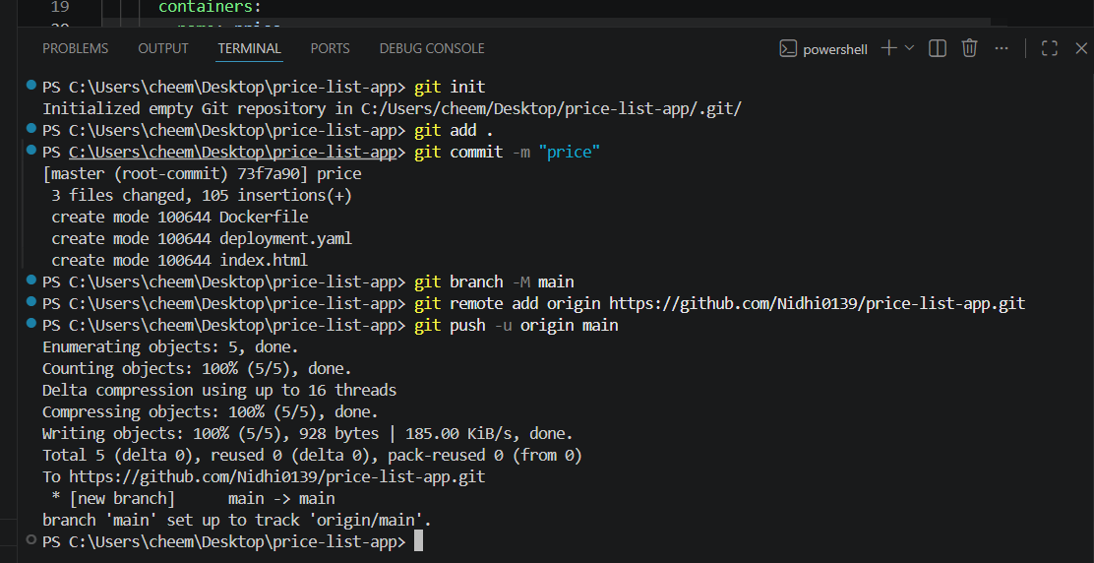

Pipeline
pipeline {
agent any

environment {
DOCKER_IMAGE = "nidhireddy11/conference-app:latest"
KUBECONFIG = "C:\\Users\\cheem\\.kube\\config"
}

stages {

stage('Clone Code') {
steps {
git branch: 'main',
url: 'https://github.com/Nidhi0139/price-list-app'
}
}

stage('Build Docker Image') {
steps {
bat 'docker build -t %DOCKER_IMAGE% .'
}
}

stage('Push Image') {
steps {
withCredentials([usernamePassword(
credentialsId: 'dockerhub-creds',
usernameVariable: 'USER',
passwordVariable: 'PASS'
)]) {

bat 'docker login -u %USER% -p %PASS%'
bat 'docker push %DOCKER_IMAGE%'
}
}
}

stage('Deploy to Kubernetes') {
steps {
bat 'kubectl apply -f deployment.yaml --validate=false || exit 0'
}
}
}

post {
success {
echo 'CI/CD Pipeline executed successfully!'
}
failure {
echo 'Pipeline failed. Please check logs.'
}
}
}
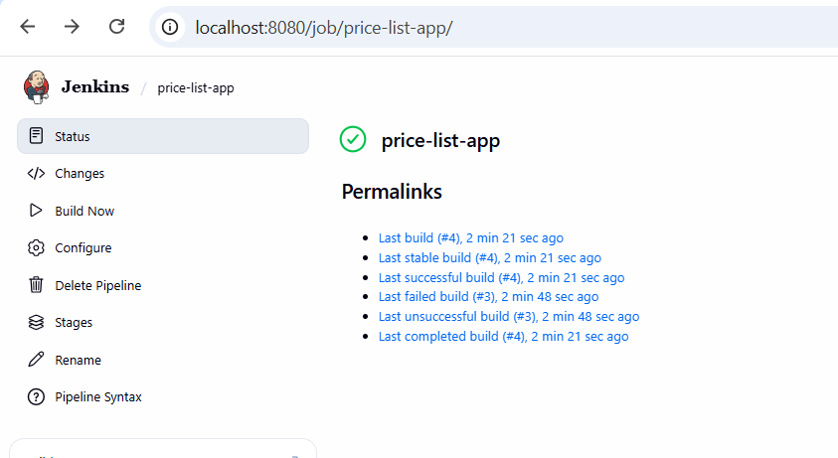

STEP 11 — Verify Kubernetes
Run:
kubectl get pods
and
kubectl get svc
Open browser:
http://localhost:300078

c. The Conference information and its full details.

Step 1 — Create a new project folder
_{Create folder:}
_{conference-info-app}
_{Inside create 3 files:}
_{conference-info-app}
│
_{├── index.html}
_{├── Dockerfile}
_{└── deployment.yaml}

Step 2 — Create the webpage
Create file:
index.html
_{<!DOCTYPE html>}
_{<html>}
_{<head>}
<title>Conference Information</title>

_{<style>}

_{body{}
_{font-family: Arial;}
_{background-color:#f4f4f4;}
}

_{h1{}
_{text-align:center;}
_{color:#2c3e50;}
}

_{.container{}
_{width:70%;}
_{margin:auto;}
_{background:white;}
_{padding:20px;}
_{border-radius:10px;}
}

_{table{}
_{width:100%;}
_{border-collapse:collapse;}
}

_{th,td{}
_{border:1px solid black;}
_{padding:10px;}
_{text-align:left;}
}

_{th{}
_{background-color:#3498db;}
_{color:white;}
}

_{</style>}
_{</head>}

_{<body>}

<h1>International Technology Conference 2026</h1>

_{<div class="container">}

_{<table>}

_{<tr>}
_{<th>Conference Name</th>}
<td>International Technology Conference</td>
_{</tr>}

_{<tr>}
_{<th>Date</th>}
_{<td>20 May 2026</td>}
_{</tr>}

_{<tr>}
_{<th>Venue</th>}
<td>VIT University Convention Hall</td>
_{</tr>}

_{<tr>}
_{<th>Chief Guest</th>}
_{<td>Dr. Ramesh Kumar</td>}
_{</tr>}

_{<tr>}
_{<th>Topics Covered</th>}
<td>Artificial Intelligence, Cloud Computing, Blockchain</td>
_{</tr>}

_{<tr>}
_{<th>Organized By</th>}
<td>Department of Information Technology</td>
_{</tr>}

_{<tr>}
_{<th>Contact</th>}
_{<td>conference@vit.edu</td>}
_{</tr>}

_{</table>}

_{</div>}

_{</body>}
_{</html>}

Step 3 — Create Dockerfile
Create file:
Dockerfile
Paste:
FROM nginx:latest
COPY index.html /usr/share/nginx/html/index.html
EXPOSE 80

Step 4 — Test Docker locally
Open terminal inside project folder.
Run:
docker build -t nidhireddy11/conference-info-app .
Then run:
docker run -p 8083:80 nidhireddy11/conference-info-app
Open browser:
http://localhost:8083

Step 5 — Create GitHub repository
Create repo:
conference-info-app
Push code:
git init
git add .
git commit -m "conference info app"
git branch -M main
git remote add origin https://github.com/Nidhi0139/conference-info-app.git
git push -u origin main

Step 6 — Create deployment.yaml
Create file:
deployment.yaml

apiVersion: apps/v1
kind: Deployment
metadata:
name: conference-app

spec:
replicas: 2

selector:
matchLabels:
app: conference

template:
metadata:
labels:
app: conference

spec:
containers:
- name: conference
image: nidhireddy11/conference-info-app:latest
ports:
- containerPort: 80

---

apiVersion: v1
kind: Service
metadata:
name: conference-service

spec:
type: NodePort

selector:
app: conference

ports:
- port: 80
targetPort: 80
nodePort: 30009

Push again: git add .
git commit -m "deployment file"
git push

Step 7 — Jenkins Pipeline
Create new Jenkins job.
Name:
conference-info-app
pipeline {
agent any

environment {
DOCKER_IMAGE = "nidhireddy11/conference-info-app:latest"
}

stages {

stage('Clone Code') {
steps {
git branch: 'main',
url: 'https://github.com/Nidhi0139/conference-info-app'
}
}

stage('Build Docker Image') {
steps {
bat 'docker build -t %DOCKER_IMAGE% .'
}
}

stage('Push Image') {
steps {
withCredentials([usernamePassword(
credentialsId: 'dockerhub-creds',
usernameVariable: 'USER',
passwordVariable: 'PASS'
)]) {

bat 'docker login -u %USER% -p %PASS%'
bat 'docker push %DOCKER_IMAGE%'
}
}
}

stage('Deploy to Kubernetes') {
steps {
bat 'kubectl apply -f deployment.yaml --validate=false'
}
}
}
}

Step 8 — Run pipeline
Click Build Now.

Step 9 — Verify Kubernetes

kubectl apply -f deployment.yaml
Run:
kubectl get pods
and
kubectl get svc
Open browser:
http://localhost:30009

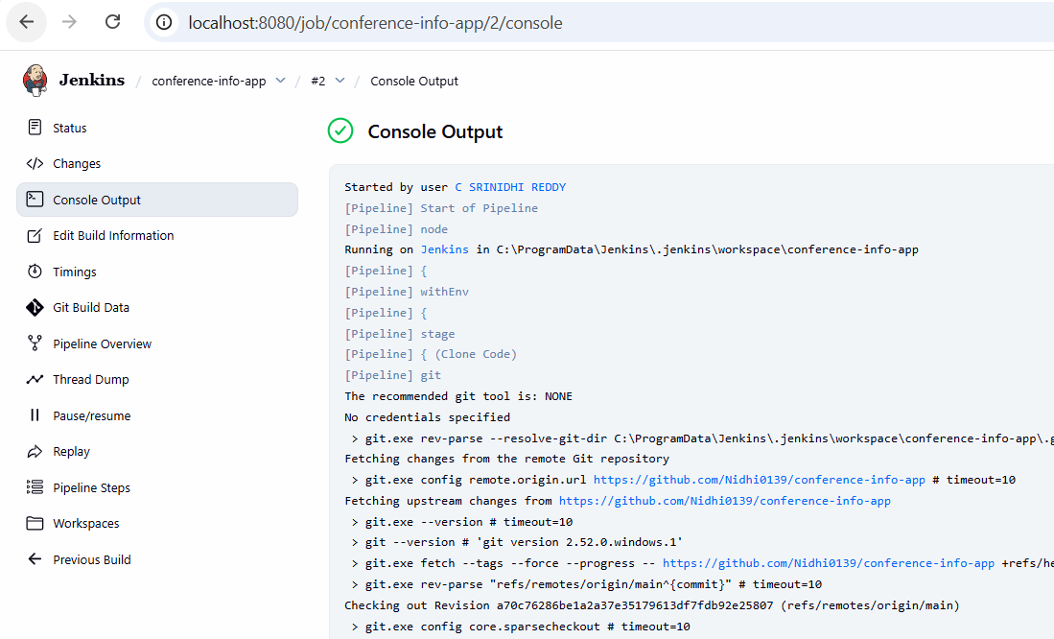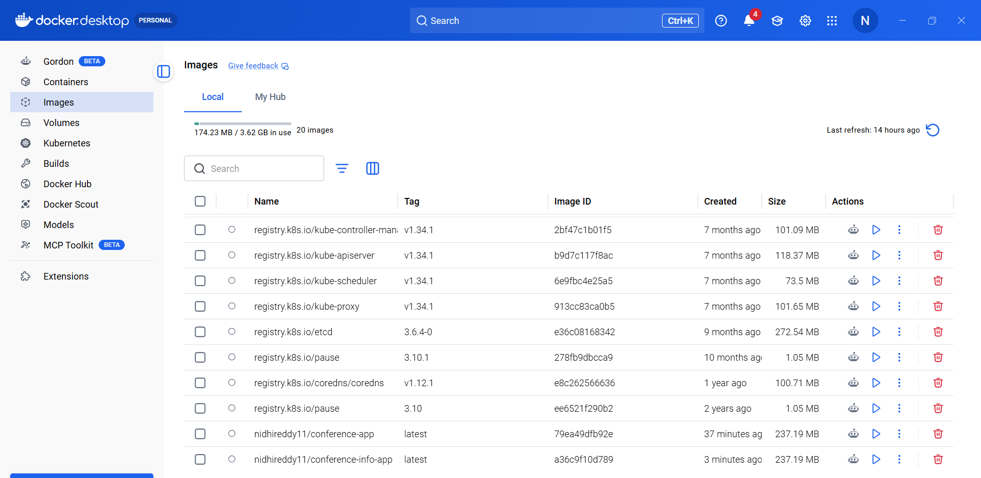
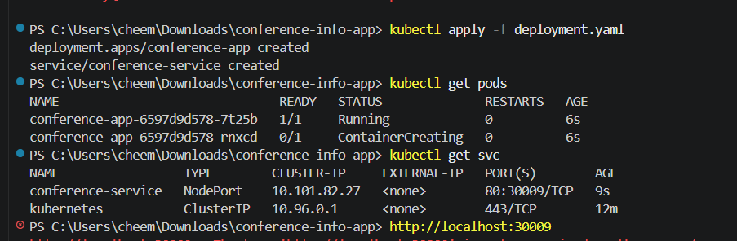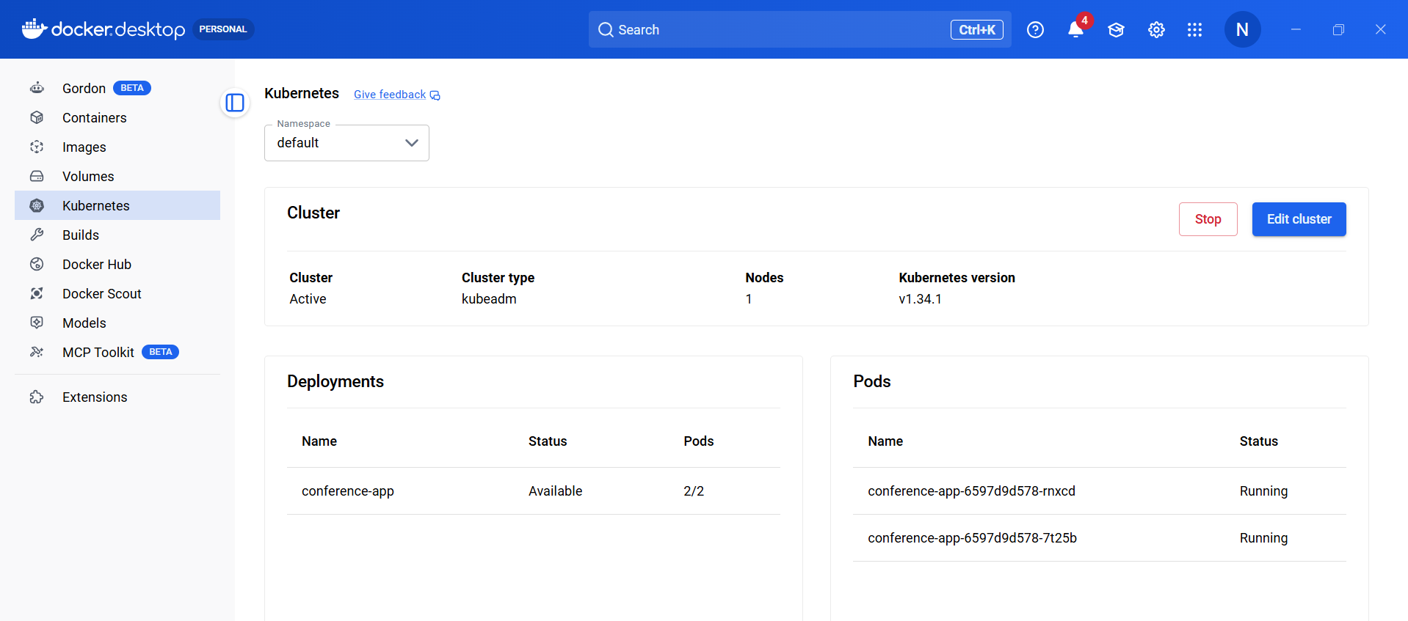
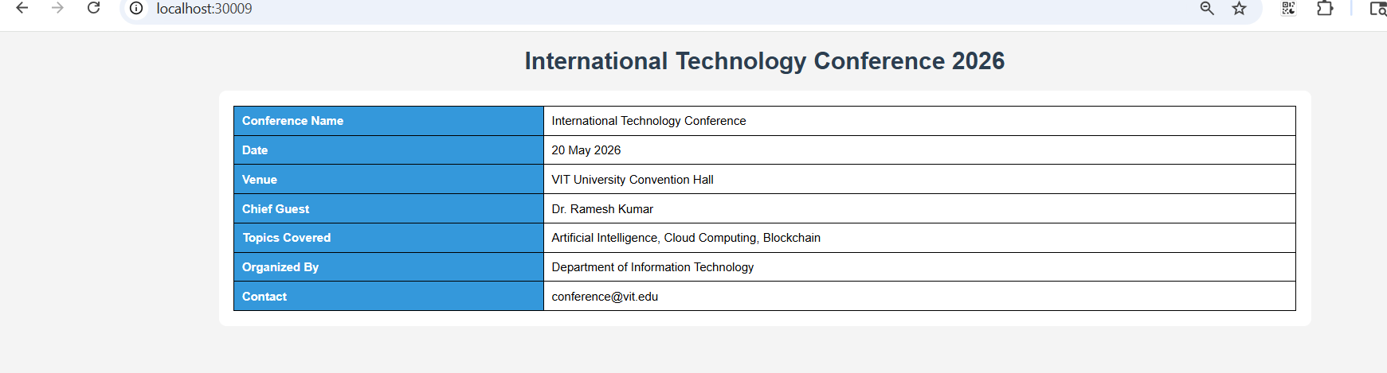
. Create some five events during Rivera.

Step 1 — Create a new project folder
Create folder:
rivera-events-app
Inside create these 3 files:
rivera-events-app
│
├── index.html
├── Dockerfile
└── deployment.yaml

Step 2 — Create the webpage
Create file:
index.html
<!DOCTYPE html>
<html>
<head>
<title>Rivera Events</title>
<style>
body{
font-family: Arial;
background:#f4f4f4;
}
h1{
text-align:center;
color:#2c3e50;
}
table{
margin:auto;
border-collapse:collapse;
width:70%;
background:white;
}
th,td{
border:1px solid black;
padding:12px;
text-align:center;
}
th{
background:#27ae60;
color:white;
}
</style>
</head>
<body>
<h1>Rivera 2026 Events</h1>
<table>
<tr>
<th>Event Name</th>
<th>Category</th>
<th>Date</th>
<th>Venue</th>
</tr>
<tr>
<td>Battle of Bands</td>
<td>Music</td>
<td>10 April 2026</td>
<td>Main Stage</td>
</tr>
<tr>
<td>Fashion Show</td>
<td>Cultural</td>
<td>11 April 2026</td>
<td>Open Auditorium</td>
</tr>
<tr>
<td>Dance Competition</td>
<td>Dance</td>
<td>12 April 2026</td>
<td>Convention Hall</td>
</tr>
<tr>
<td>Stand-up Comedy</td>
<td>Entertainment</td>
<td>12 April 2026</td>
<td>Mini Auditorium</td>
</tr>
<tr>
<td>Photography Contest</td>
<td>Art</td>
<td>13 April 2026</td>
<td>Campus Lawn</td>
</tr>
</table>
</body>
</html>

Step 3 — Create Dockerfile
Create file:
Dockerfile
Paste:
FROM nginx:latest
COPY index.html /usr/share/nginx/html/index.html
EXPOSE 80

Step 4 — Test Docker locally
Open terminal inside the folder.
Run:
docker build -t nidhireddy11/rivera-events-app .
Run container:
docker run -p 8084:80 nidhireddy11/rivera-events-app
Open browser:
http://localhost:8084

Step 5 — Create GitHub repository
Create repo:
rivera-events-app
Push code:
git init
git add .
git commit -m "rivera events page"
git branch -M main
git remote add origin https://github.com/Nidhi0139/rivera-events-app.git
git push -u origin main

Step 6 — Create Kubernetes deployment
Create file:
deployment.yaml

apiVersion: apps/v1
kind: Deployment
metadata:
name: rivera-app

spec:
replicas: 2

selector:
matchLabels:
app: rivera

template:
metadata:
labels:
app: rivera

spec:
containers:
- name: rivera
image: nidhireddy11/rivera-events-app:latest
ports:
- containerPort: 80

---

apiVersion: v1
kind: Service
metadata:
name: rivera-service

spec:
type: NodePort

selector:
app: rivera

ports:
- port: 80
targetPort: 80
nodePort: 30010

Push again:
git add .
git commit -m "deployment file"
git push

Step 7 — Jenkins Pipeline
Create Jenkins job:
rivera-events-app

pipeline {
agent any

environment {
DOCKER_IMAGE = "nidhireddy11/rivera-events-app:latest"
}

stages {

stage('Clone Code') {
steps {
git branch: 'main',
url: 'https://github.com/Nidhi0139/rivera-events-app'
}
}

stage('Build Docker Image') {
steps {
bat 'docker build -t %DOCKER_IMAGE% .'
}
}

stage('Push Image') {
steps {
withCredentials([usernamePassword(
credentialsId: 'dockerhub-creds',
usernameVariable: 'USER',
passwordVariable: 'PASS'
)]) {

bat 'docker login -u %USER% -p %PASS%'
bat 'docker push %DOCKER_IMAGE%'
}
}
}

stage('Deploy to Kubernetes') {
steps {
bat 'kubectl apply -f deployment.yaml --validate=false || exit 0'
}
}
}
}

Step 8 — Verify Kubernetes

kubectl apply -f deployment.yaml
Run:
kubectl get pods
and
kubectl get svc
Open browser:
http://localhost:30010

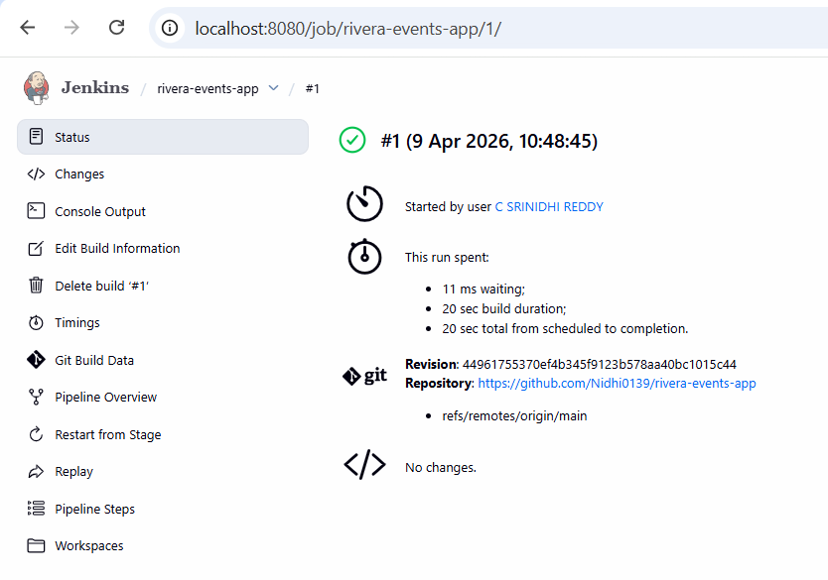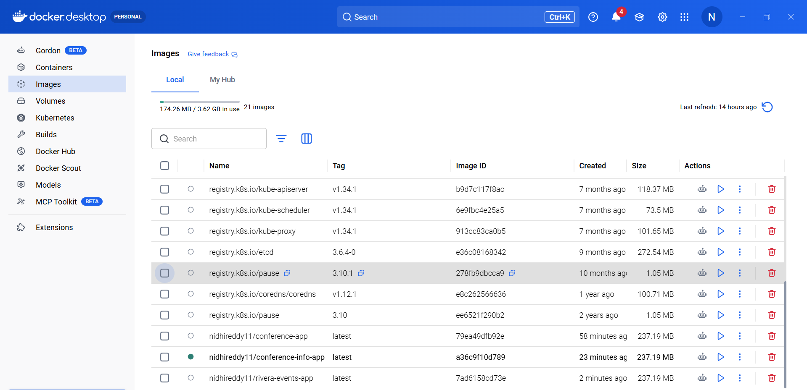
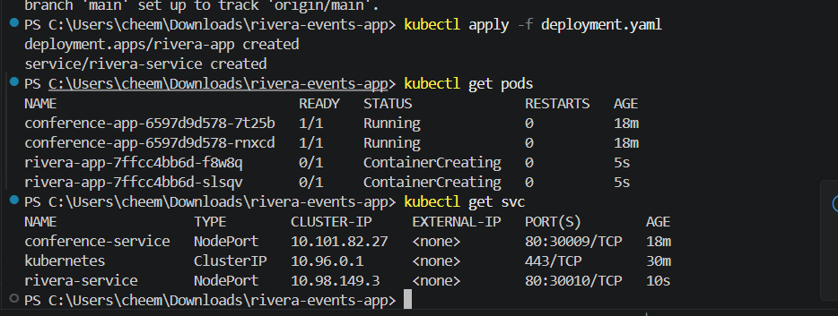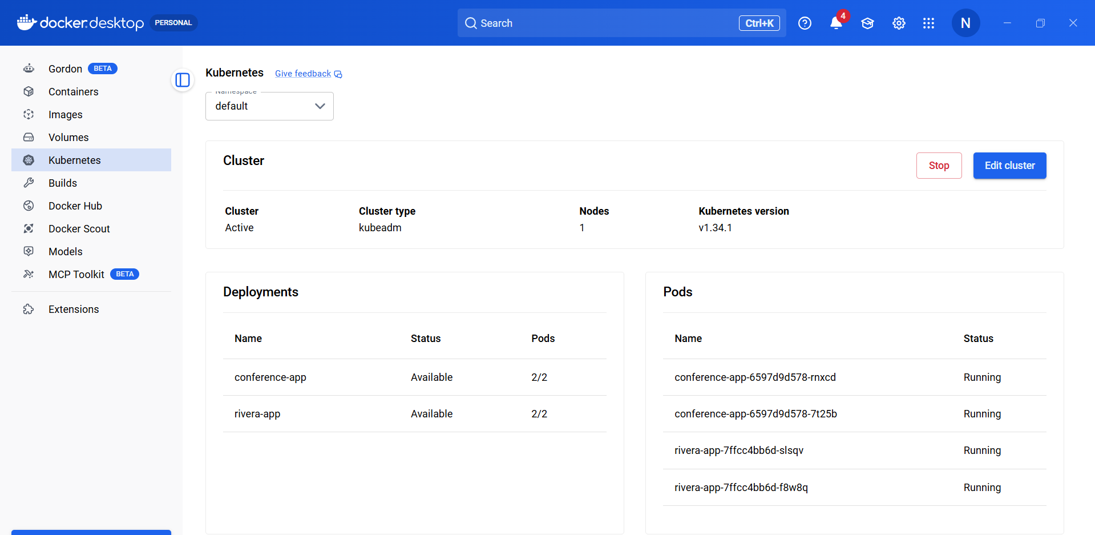

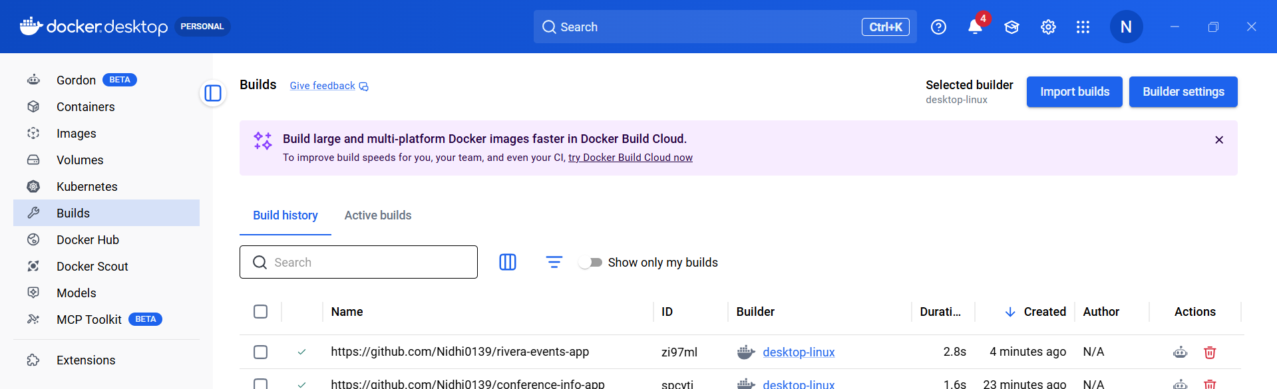
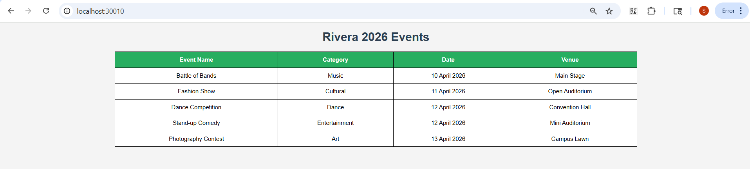

a. The student results

Step 1 — Create new project folder
Create folder:
student-results-app
Inside create 3 files:
student-results-app
│
├── index.html
├── Dockerfile
└── deployment.yaml

Step 2 — Create Student Results Webpage
Create file:
index.html

<!DOCTYPE html>
<html>
<head>
<title>Student Results</title>

<style>

body{
font-family: Arial;
background:#f4f4f4;
}

h1{
text-align:center;
color:#2c3e50;
}

table{
margin:auto;
border-collapse:collapse;
width:70%;
background:white;
}

th,td{
border:1px solid black;
padding:10px;
text-align:center;
}

th{
background:#3498db;
color:white;
}

</style>

</head>

<body>

<h1>Student Results</h1>

<table>

<tr>
<th>Student Name</th>
<th>Subject</th>
<th>Marks</th>
<th>Grade</th>
</tr>

<tr>
<td>Rahul</td>
<td>Mathematics</td>
<td>90</td>
<td>A+</td>
</tr>

<tr>
<td>Sneha</td>
<td>Physics</td>
<td>85</td>
<td>A</td>
</tr>

<tr>
<td>Arjun</td>
<td>Chemistry</td>
<td>78</td>
<td>B+</td>
</tr>

<tr>
<td>Pooja</td>
<td>Computer Science</td>
<td>92</td>
<td>A+</td>
</tr>

<tr>
<td>Kiran</td>
<td>English</td>
<td>80</td>
<td>A</td>
</tr>

</table>

</body>
</html>

Step 3 — Create Dockerfile
Create file:
Dockerfile
Paste:
FROM nginx:latest
COPY index.html /usr/share/nginx/html/index.html
EXPOSE 80

Step 4 — Test Docker locally
Open terminal in this folder.
Build image:
docker build -t nidhireddy11/student-results-app .
Run container:
docker run -p 8085:80 nidhireddy11/student-results-app
Open browser:
http://localhost:8085

Step 5 — Create GitHub Repository
Create repo:
student-results-app
Push code:
git init
git add .
git commit -m "student results page"
git branch -M main
git remote add origin https://github.com/Nidhi0139/student-results-app.git
git push -u origin main

Step 6 — Create Kubernetes Deployment
Create:
deployment.yaml

apiVersion: apps/v1
kind: Deployment
metadata:
name: student-results-app

spec:
replicas: 2

selector:
matchLabels:
app: results

template:
metadata:
labels:
app: results

spec:
containers:
- name: results
image: nidhireddy11/student-results-app:latest
ports:
- containerPort: 80

---

apiVersion: v1
kind: Service
metadata:
name: results-service

spec:
type: NodePort

selector:
app: results

ports:
- port: 80
targetPort: 80
nodePort: 30011

Push again:
git add .
git commit -m "deployment file"
git push

Step 7 — Jenkins Pipeline
Create new Jenkins job:
student-results-app

pipeline {
agent any

environment {
DOCKER_IMAGE = "nidhireddy11/student-results-app:latest"
}

stages {

stage('Clone Code') {
steps {
git branch: 'main',
url: 'https://github.com/Nidhi0139/student-results-app'
}
}

stage('Build Docker Image') {
steps {
bat 'docker build -t %DOCKER_IMAGE% .'
}
}

stage('Push Image') {
steps {
withCredentials([usernamePassword(
credentialsId: 'dockerhub-creds',
usernameVariable: 'USER',
passwordVariable: 'PASS'
)]) {

bat 'docker login -u %USER% -p %PASS%'
bat 'docker push %DOCKER_IMAGE%'
}
}
}

stage('Deploy to Kubernetes') {
steps {
bat 'kubectl apply -f deployment.yaml --validate=false || exit 0'
}
}
}
}

Step 8 — Verify Kubernetes

kubectl apply -f deployment.yaml
Run:
kubectl get pods
and
kubectl get svc
Open browser:
http://localhost:30011

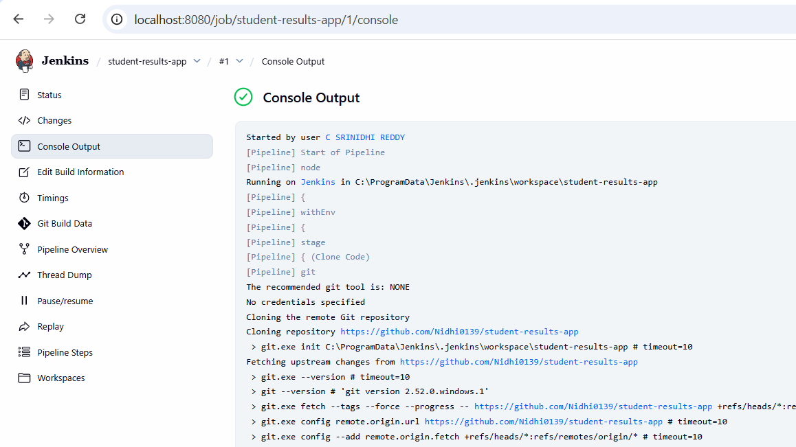
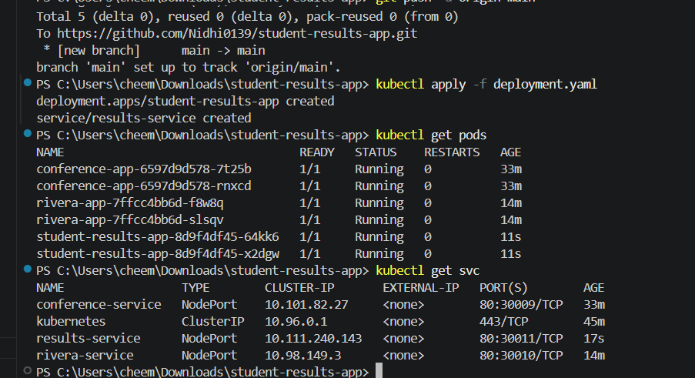
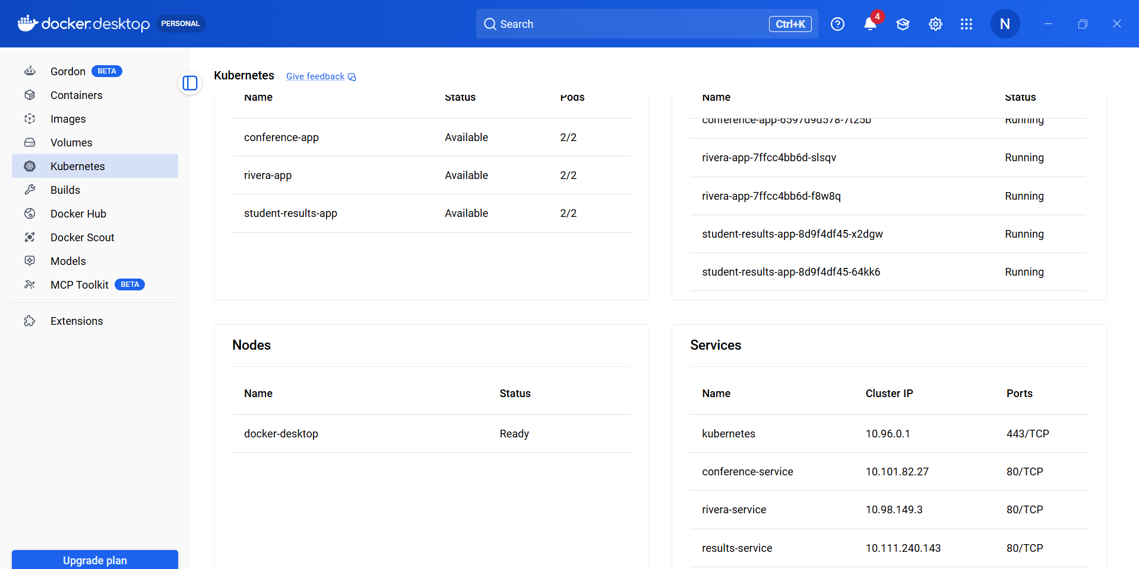

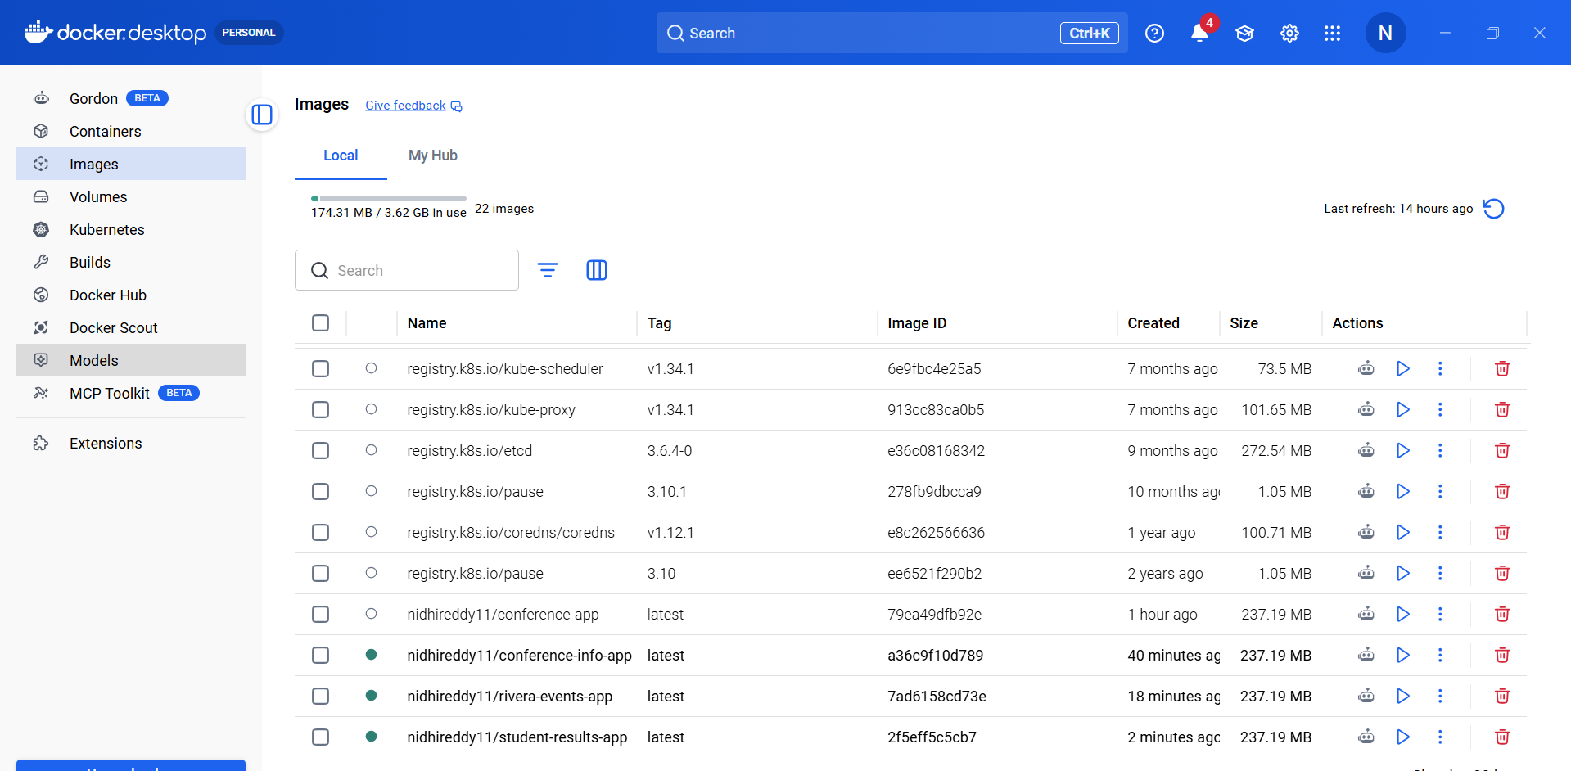
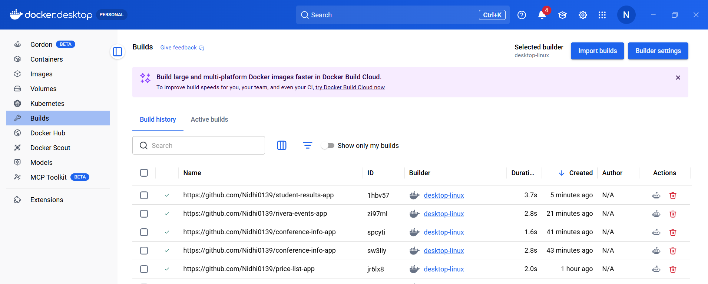

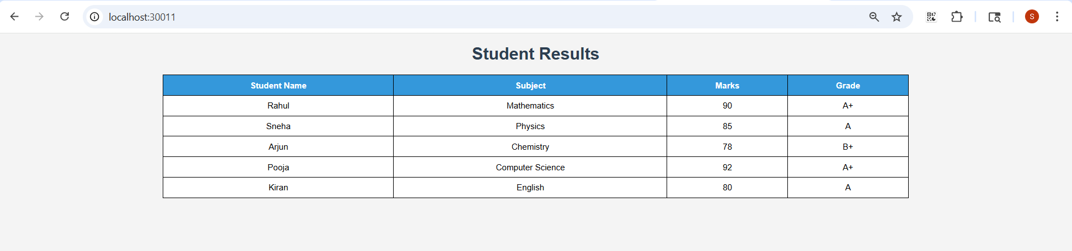

Simple Java Console App (Baseline CI/CD)
TASK : Create Maven project with Junit tests
• Create a Maven based application by following standard Maven directory structure.
• Write the code in Visual Studio and push it to your GITHUB repository.
• Modify the code and commit the updates back in GITHUB.
• Using Jenkins configure the job as pipeline and create the stages for the Continuous Integration process.
• Containerize the application using Dockerfile and display the stages in stage view in Jenkins.

a. Addition operation
Open vscode -> folder addition-app
addition-app/
├── src/
│ ├── main/java/com/example/App.java
│ └── test/java/com/example/AppTest.java
└── pom.xml
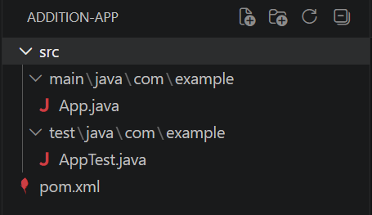
pom.xml
<project xmlns="http://maven.apache.org/POM/4.0.0"
xmlns:xsi="http://www.w3.org/2001/XMLSchema-instance"
xsi:schemaLocation="http://maven.apache.org/POM/4.0.0
http://maven.apache.org/xsd/maven-4.0.0.xsd">
<modelVersion>4.0.0</modelVersion>
<groupId>com.example</groupId>
<artifactId>addition-app</artifactId>
<version>1.0-SNAPSHOT</version>
<dependencies>
<dependency>
<groupId>junit</groupId>
<artifactId>junit</artifactId>
<version>4.13.2</version>
<scope>test</scope>
</dependency>
</dependencies>
</project>
App.java
package com.example;
public class App {
public int add(int a, int b) {
return a + b;
}
public static void main(String[] args) {
App obj = new App();
System.out.println("Result = " + obj.add(5, 3));
}
}
AppTest.java
package com.example;
import static org.junit.Assert.assertEquals;
import org.junit.Test;
public class AppTest {
@Test
public void testAdd() {
App obj = new App();
assertEquals(8, obj.add(5, 3));
}
}
Terminal -> mvn clean package
Create git repo, then in terminal
git init
git add .
git commit -m "first commit"
git branch -M main
git remote add origin https://github.com/Srilaya18/add.git
git push -u origin main
Modify Code & Commit Again
In App.java -> System.out.println("Result = " + obj.add(10, 2));
git add .
git commit -m "Updated addition"
git push
Create pipeline and Script
pipeline {
agent any
stages {
stage('Clone Code') {
steps {
git branch: 'main',
url: 'https://github.com/Nidhi0139/addition-app'
}
}
stage('Build Project') {
steps {
bat 'mvn clean compile'
}
}
stage('Run Tests') {
steps {
bat 'mvn test'
}
}
stage('Package Application') {
steps {
bat 'mvn package'
}
}
}
}
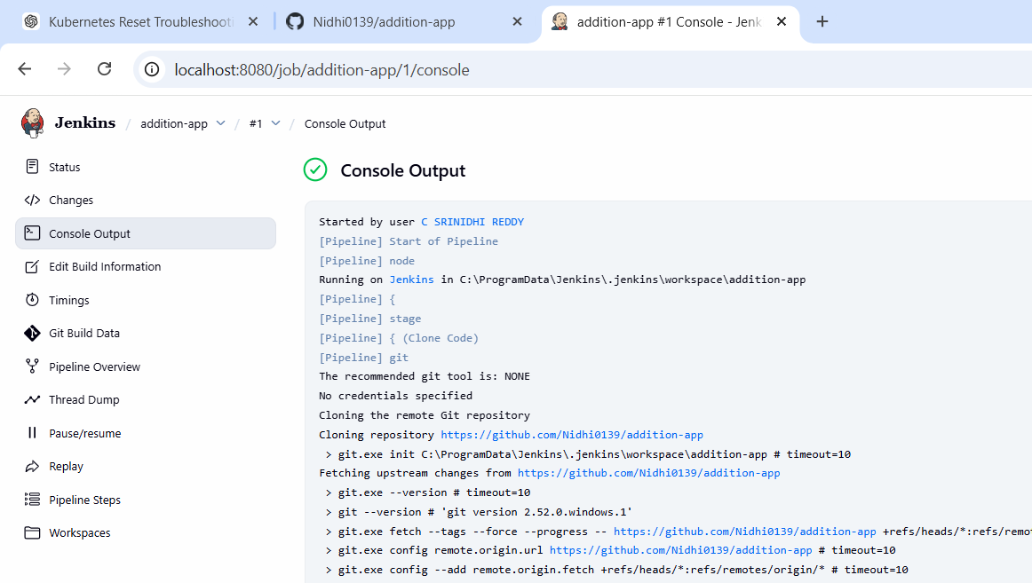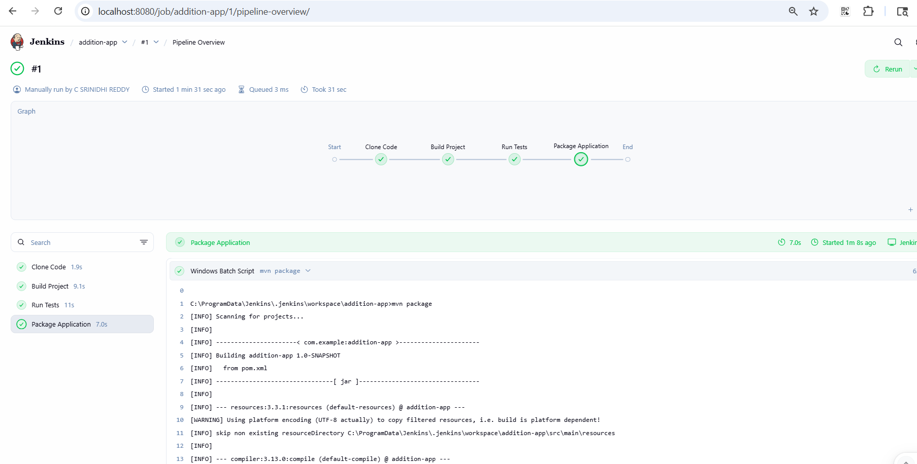
Create Dockerfile
FROM eclipse-temurin:17-jdk
WORKDIR /app
COPY target/addition-app-1.0-SNAPSHOT.jar app.jar
CMD ["java", "-jar", "app.jar"]
Commit Again
git add .
git commit -m "Updated"
git push
Update the pipeline script completely
pipeline {
agent any
environment {
DOCKER_IMAGE = "nidhireddy11/addition-app"
}
stages {
stage('Clone Code') {
steps {
git branch: 'main',
url: 'https://github.com/Nidhi0139/addition-app'
}
}
stage('Build Project') {
steps {
bat 'mvn clean compile'
}
}
stage('Run Tests') {
steps {
bat 'mvn test'
}
}
stage('Package Application') {
steps {
bat 'mvn package'
}
}
stage('Build Docker Image') {
steps {
bat 'docker build -t %DOCKER_IMAGE% .'
}
}
}
}
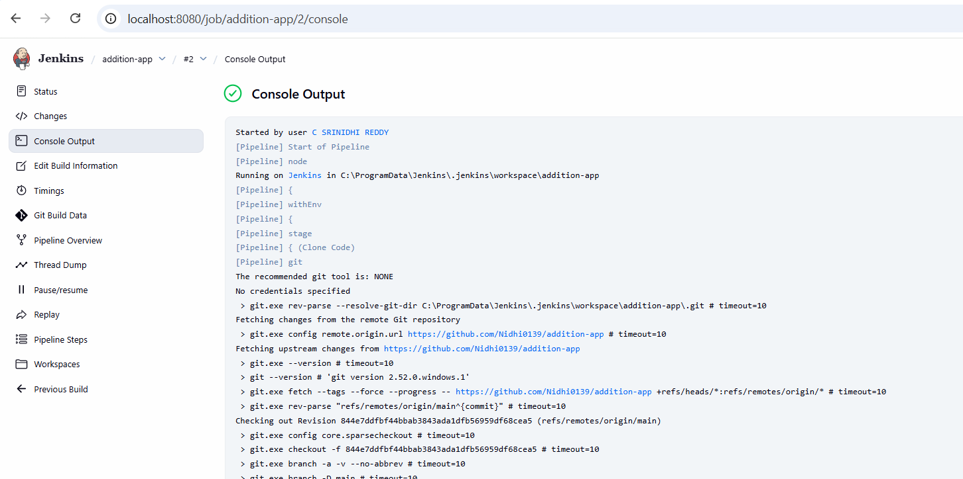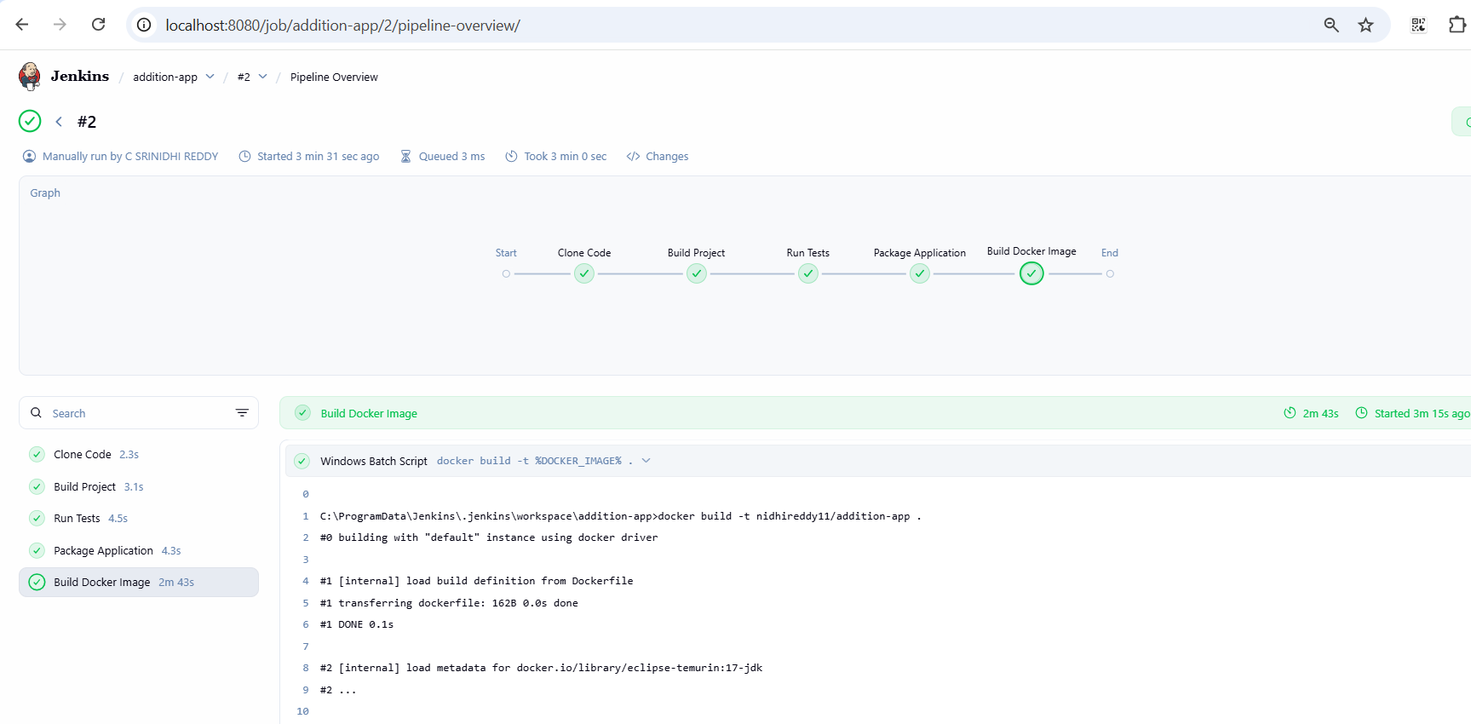
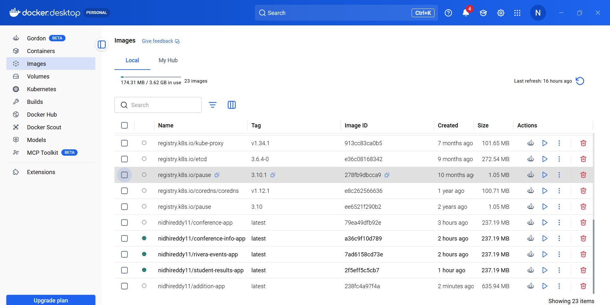

b. Evenodd numbers

b. Even-Odd Numbers — Step by Step

Step 1 — Create Project Folder
Open VS Code
Create a folder:
evenodd-app
Inside create this structure:
evenodd-app
│
├── src
│ ├── main
│ │ └── java
│ │ └── com
│ │ └── example
│ │ └── App.java
│ │
│ └── test
│ └── java
│ └── com
│ └── example
│ └── AppTest.java
│
└── pom.xml

Step 2 — Create pom.xml

Create file pom.xml in root folder.

<project xmlns="http://maven.apache.org/POM/4.0.0">
<modelVersion>4.0.0</modelVersion>

<groupId>com.example</groupId>
<artifactId>evenodd-app</artifactId>
<version>1.0</version>

<dependencies>
<dependency>
<groupId>junit</groupId>
<artifactId>junit</artifactId>
<version>4.13.2</version>
<scope>test</scope>
</dependency>
</dependencies>
</project>

Step 3 — Create App.java
Location
src/main/java/com/example/App.java

package com.example;

public class App {

public String checkEvenOdd(int num) {

if (num % 2 == 0)
return "Even";
else
return "Odd";
}

public static void main(String[] args) {

App obj = new App();

System.out.println(obj.checkEvenOdd(4));
}
}

Step 4 — Create AppTest.java
Location
src/test/java/com/example/AppTest.java

package com.example;

import static org.junit.Assert.assertEquals;
import org.junit.Test;

public class AppTest {

@Test
public void testEvenOdd() {

App obj = new App();

assertEquals("Even", obj.checkEvenOdd(4));
}
}

Step 5 — Run Maven Project
Open Terminal in VS Code
Run:
mvn clean package
If successful you will see
BUILD SUCCESS

Step 6 — Push Project to GitHub
Create GitHub repo
Example:
evenodd-app
Now run in terminal:
git init
git add .
git commit -m "first commit"
git branch -M main
git remote add origin https://github.com/YOURUSERNAME/evenodd-app.git
git push -u origin main

Step 7 — Modify Code (Second Commit)
Change main method.
System.out.println(obj.checkEvenOdd(7));
Then commit again.
git add .
git commit -m "Updated even odd logic"
git push

Step 8 — Create Jenkins Pipeline
Create Pipeline Job
Name:
evenodd-pipeline

pipeline {

agent any

stages {

stage('Clone') {

steps {

git branch: 'main',
url: 'https://github.com/Nidhi0139/evenodd-app'
}
}

stage('Build') {

steps {

bat 'mvn clean package'
}
}

stage('Test') {

steps {

bat 'mvn test'
}
}

}

}

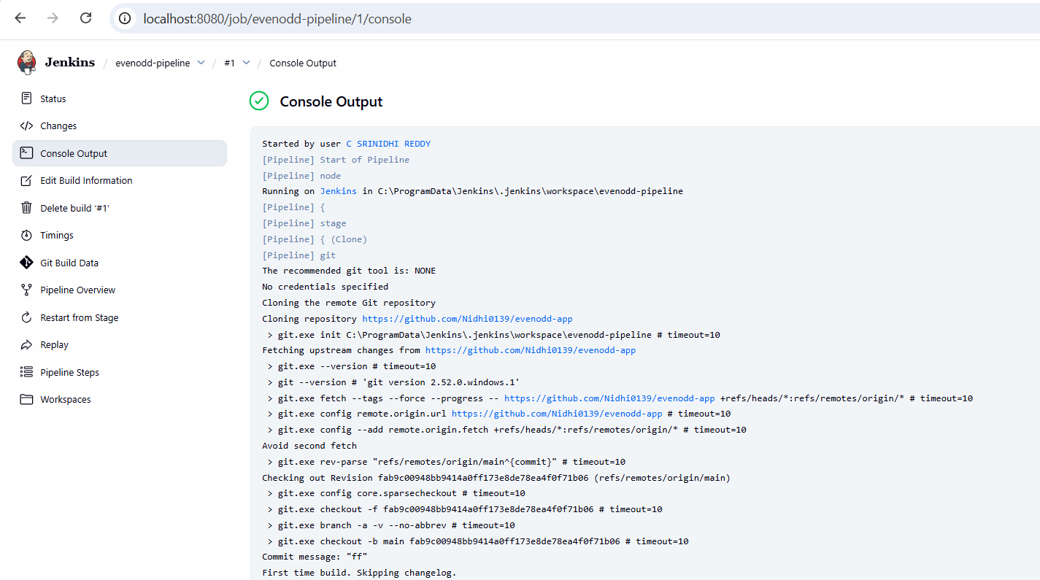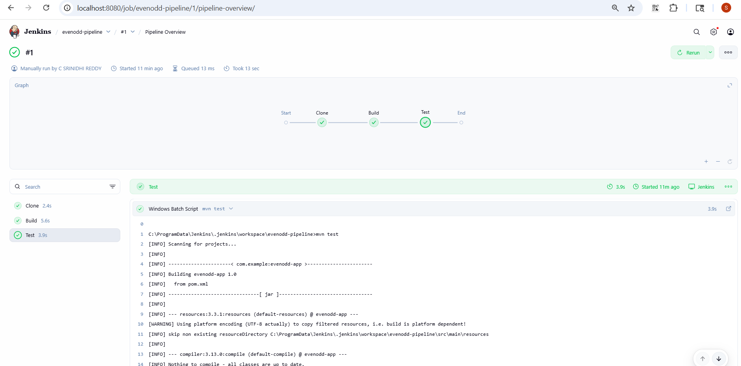

Step 9 — Create Dockerfile
Create file Dockerfile
FROM eclipse-temurin:17-jdk
WORKDIR /app
COPY target/evenodd-app-1.0.jar app.jar
CMD ["java", "-jar", "app.jar"]

Step 10 — Push Again
git add .
git commit -m "Added Dockerfile"
git push

Step 11 — Update Jenkins Pipeline

pipeline {

agent any

stages {

stage('Clone') {

steps {

git branch: 'main',

url: 'https://github.com/Nidhi0139/evenodd-app'

}

}

stage('Build') {

steps {

bat 'mvn clean package'

}

}

stage('Test') {

steps {

bat 'mvn test'

}

}

stage('Docker Build') {

steps {

bat 'docker build -t evenodd-app .'

}

}

}

}

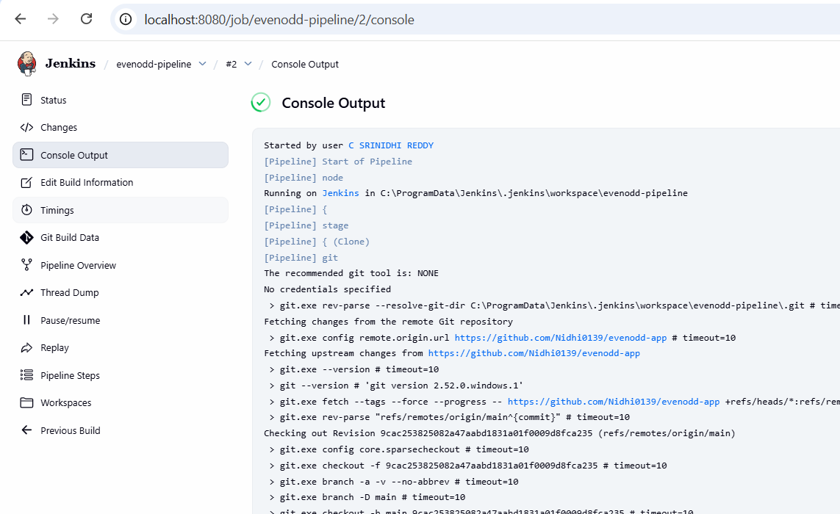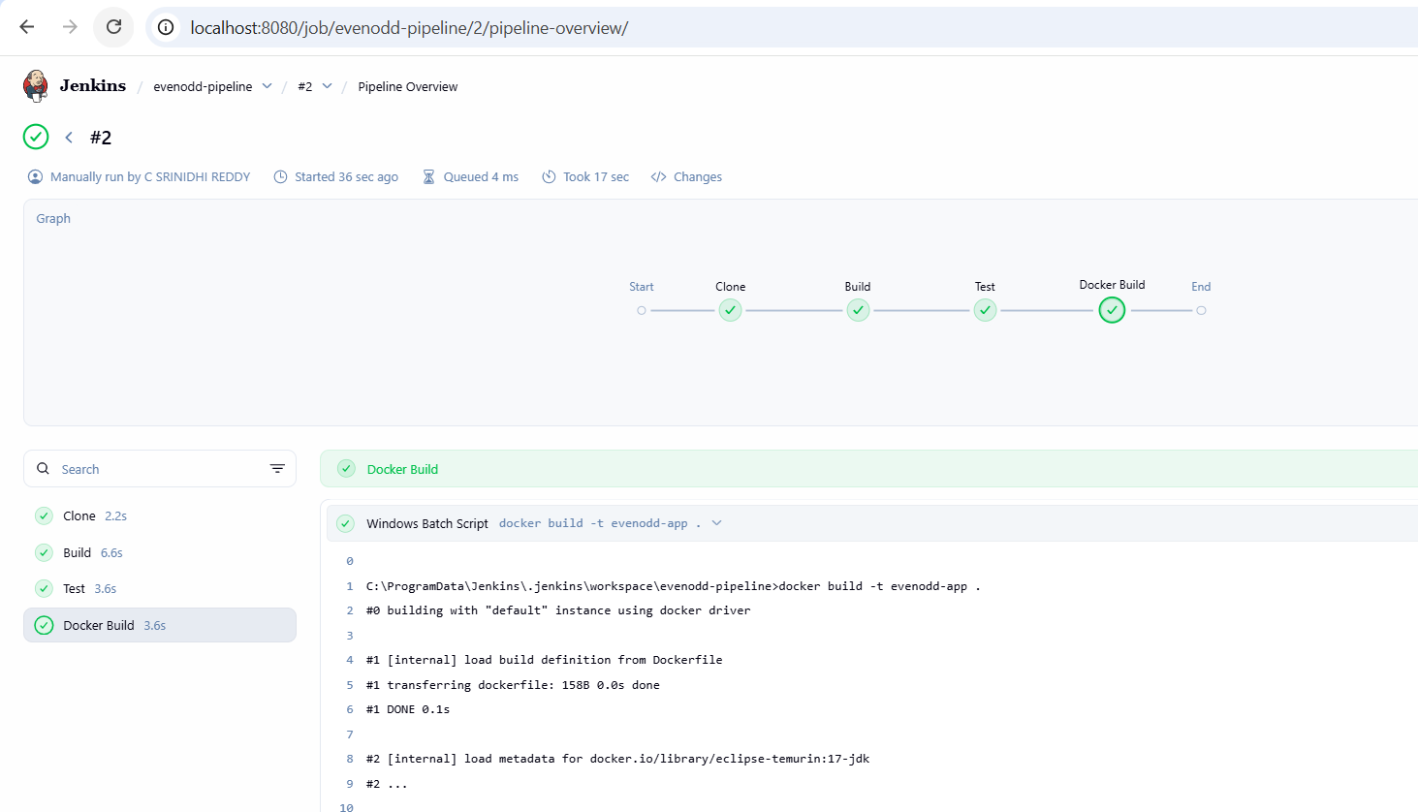
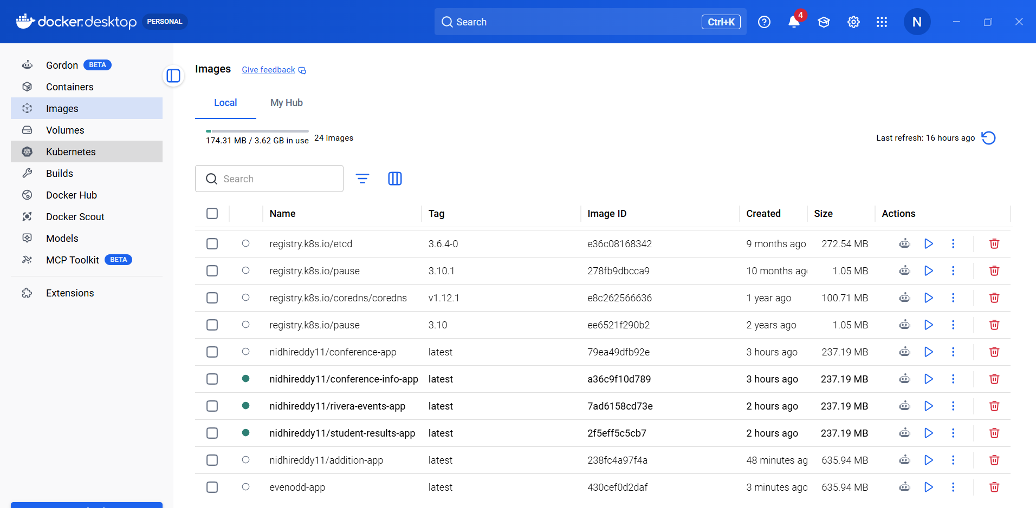

c. Multiplication — Step by Step

Step 1 — Create Project Folder
Open VS Code
Create folder:
multiplication-app
Project structure:
multiplication-app
│
├── src
│ ├── main
│ │ └── java
│ │ └── com
│ │ └── example
│ │ └── App.java
│ │
│ └── test
│ └── java
│ └── com
│ └── example
│ └── AppTest.java
│
└── pom.xml

Step 2 — Create pom.xml
Create pom.xml
<project xmlns="http://maven.apache.org/POM/4.0.0">

<modelVersion>4.0.0</modelVersion>

<groupId>com.example</groupId>
<artifactId>multiplication-app</artifactId>
<version>1.0</version>

<dependencies>

<dependency>
<groupId>junit</groupId>
<artifactId>junit</artifactId>
<version>4.13.2</version>
<scope>test</scope>
</dependency>

</dependencies>

</project>

Step 3 — Create App.java
Location
src/main/java/com/example/App.java

package com.example;

public class App {

public int multiply(int a, int b) {

return a * b;
}

public static void main(String[] args) {

App obj = new App();

System.out.println("Result = " + obj.multiply(5,3));
}

}

Step 4 — Create AppTest.java
Location
src/test/java/com/example/AppTest.java

package com.example;

import static org.junit.Assert.assertEquals;
import org.junit.Test;

public class AppTest {

@Test
public void testMultiply() {

App obj = new App();

assertEquals(15, obj.multiply(5,3));
}

}

Step 5 — Run Maven Project
Open Terminal in VS Code
Run:
mvn clean package
Output should show
BUILD SUCCESS

Step 6 — Push Project to GitHub
Create GitHub repository
Example
multiplication-app
Then run:
git init
git add .
git commit -m "first commit"
git branch -M main
git remote add origin https://github.com/YOURUSERNAME/multiplication-app.git
git push -u origin main

Step 7 — Modify Code (Second Commit)
Change main method
System.out.println("Result = " + obj.multiply(10,2));
Commit again:
git add .
git commit -m "Updated multiplication"
git push

Step 8 — Create Jenkins Pipeline
Create Pipeline Job
Name
multiplication-pipeline

pipeline {

agent any

stages {

stage('Clone') {

steps {

git branch: 'main',
url: 'https://github.com/YOURUSERNAME/multiplication-app'
}
}

stage('Build') {

steps {

bat 'mvn clean package'
}
}

stage('Test') {

steps {

bat 'mvn test'
}
}

}

}

Step 9 — Create Dockerfile
Create Dockerfile
FROM eclipse-temurin:17-jdk
WORKDIR /app
COPY target/multiplication-app-1.0.jar app.jar
CMD ["java","-jar","app.jar"]

Step 10 — Push Again
git add .
git commit -m "Added Dockerfile"
git push

Step 11 — Update Jenkins Pipeline
pipeline {

agent any

stages {

stage('Clone') {

steps {

git branch: 'main',
url: 'https://github.com/YOURUSERNAME/multiplication-app'
}
}

stage('Build') {

steps {

bat 'mvn clean package'
}
}

stage('Test') {

steps {

bat 'mvn test'
}
}

stage('Docker Build') {

steps {

bat 'docker build -t multiplication-app .'
}
}

}

}

Step 1 — Create Project Folder
Open VS Code
Create folder:
factorial-app
Project structure:
factorial-app
│
├── src
│ ├── main
│ │ └── java
│ │ └── com
│ │ └── example
│ │ └── App.java
│ │
│ └── test
│ └── java
│ └── com
│ └── example
│ └── AppTest.java
│
└── pom.xml

Step 2 — Create pom.xml
Create pom.xml
<project xmlns="http://maven.apache.org/POM/4.0.0">

<modelVersion>4.0.0</modelVersion>

<groupId>com.example</groupId>
<artifactId>factorial-app</artifactId>
<version>1.0</version>

<dependencies>

<dependency>
<groupId>junit</groupId>
<artifactId>junit</artifactId>
<version>4.13.2</version>
<scope>test</scope>
</dependency>

</dependencies>

</project>

Step 3 — Create App.java
Location
src/main/java/com/example/App.java

package com.example;

public class App {

public int factorial(int n) {

int fact = 1;

for(int i=1;i<=n;i++)
{
fact = fact * i;
}

return fact;
}

public static void main(String[] args) {

App obj = new App();

System.out.println("Result = " + obj.factorial(5));
}
}

Step 4 — Create AppTest.java
Location
src/test/java/com/example/AppTest.java

package com.example;

import static org.junit.Assert.assertEquals;
import org.junit.Test;

public class AppTest {

@Test
public void testFactorial() {

App obj = new App();

assertEquals(120, obj.factorial(5));
}

}

Step 5 — Run Maven Project
Open VS Code terminal
Run
mvn clean package
You should see
BUILD SUCCESS

Step 6 — Push to GitHub
Create new repo
factorial-app
Then run:
git init
git add .
git commit -m "first commit"
git branch -M main
git remote add origin https://github.com/YOURUSERNAME/factorial-app.git
git push -u origin main

Step 7 — Modify Code (Second Commit)
Change main method
System.out.println("Result = " + obj.factorial(6));
Then commit again
git add .
git commit -m "Updated factorial"
git push

Step 8 — Create Jenkins Pipeline
Create pipeline job
factorial-pipeline

pipeline {

agent any

stages {

stage('Clone') {

steps {

git branch: 'main',
url: 'https://github.com/YOURUSERNAME/factorial-app'
}
}

stage('Build') {

steps {

bat 'mvn clean package'
}
}

stage('Test') {

steps {

bat 'mvn test'
}
}

}

}

Step 9 — Create Dockerfile
Create file Dockerfile
FROM eclipse-temurin:17-jdk
WORKDIR /app
COPY target/factorial-app-1.0.jar app.jar
CMD ["java","-jar","app.jar"]

Step 10 — Push Again
git add .
git commit -m "Added Dockerfile"
git push

Step 11 — Update Jenkins Pipeline

pipeline {

agent any

stages {

stage('Clone') {

steps {

git branch: 'main',
url: 'https://github.com/YOURUSERNAME/factorial-app'
}
}

stage('Build') {

steps {

bat 'mvn clean package'
}
}

stage('Test') {

steps {

bat 'mvn test'
}
}

stage('Docker Build') {

steps {

bat 'docker build -t factorial-app .'
}
}

}

}

e. Prime Number — Step by Step

Step 1 — Create Project Folder
Open VS Code
Create folder:
prime-app
Project structure:
prime-app
│
├── src
│ ├── main
│ │ └── java
│ │ └── com
│ │ └── example
│ │ └── App.java
│ │
│ └── test
│ └── java
│ └── com
│ └── example
│ └── AppTest.java
│
└── pom.xml

Step 2 — Create pom.xml
Create file pom.xml

<project xmlns="http://maven.apache.org/POM/4.0.0">

<modelVersion>4.0.0</modelVersion>

<groupId>com.example</groupId>
<artifactId>prime-app</artifactId>
<version>1.0</version>

<dependencies>

<dependency>
<groupId>junit</groupId>
<artifactId>junit</artifactId>
<version>4.13.2</version>
<scope>test</scope>
</dependency>

</dependencies>

</project>

Step 3 — Create App.java
Location
src/main/java/com/example/App.java

package com.example;

public class App {

public boolean isPrime(int n) {

if(n <= 1)
return false;

for(int i = 2; i < n; i++)
{
if(n % i == 0)
return false;
}

return true;
}

public static void main(String[] args) {

App obj = new App();

System.out.println(obj.isPrime(7));
}
}

Step 4 — Create AppTest.java
Location
src/test/java/com/example/AppTest.java

package com.example;

import static org.junit.Assert.assertEquals;
import org.junit.Test;

public class AppTest {

@Test
public void testPrime() {

App obj = new App();

assertEquals(true, obj.isPrime(7));
}
}

Step 5 — Run Maven Project
Open VS Code Terminal
Run
mvn clean package
You should see
BUILD SUCCESS

Step 6 — Push Project to GitHub
Create new repository
prime-app
Then run in terminal
git init
git add .
git commit -m "first commit"
git branch -M main
git remote add origin https://github.com/YOURUSERNAME/prime-app.git
git push -u origin main

Step 7 — Modify Code (Second Commit)
Change main method
System.out.println(obj.isPrime(11));
Then commit again
git add .
git commit -m "Updated prime number"
git push

Step 8 — Create Jenkins Pipeline
Create new pipeline job
prime-pipeline

pipeline {

agent any

stages {

stage('Clone') {

steps {

git branch: 'main',
url: 'https://github.com/YOURUSERNAME/prime-app'
}
}

stage('Build') {

steps {

bat 'mvn clean package'
}
}

stage('Test') {

steps {

bat 'mvn test'
}
}

}

}

Step 9 — Create Dockerfile
Create file Dockerfile
FROM eclipse-temurin:17-jdk
WORKDIR /app
COPY target/prime-app-1.0.jar app.jar
CMD ["java","-jar","app.jar"]

Step 10 — Push Again
git add .
git commit -m "Added Dockerfile"
git push

Step 11 — Update Jenkins Pipeline
Full pipeline
pipeline {

agent any

stages {

stage('Clone') {

steps {

git branch: 'main',
url: 'https://github.com/YOURUSERNAME/prime-app'
}
}

stage('Build') {

steps {

bat 'mvn clean package'
}
}

stage('Test') {

steps {

bat 'mvn test'
}
}

stage('Docker Build') {

steps {

bat 'docker build -t prime-app .'
}
}

}

}

